
SHIRE HIGHLANDS EDUCATION DIVISION
2026 MALAWI SCHOOL CERTIFICATE OF EDUCATION MOCK
EXAMINATION

ADDITIONAL MATHEMATICS

Subject Number: M123/II
Date: Friday, 13 March 2026 Time Allowed: 2 hours 30 min
8:00 - 10:30 am

PAPER II
(100 Marks)
Question Number | Tick if answered | Do not write in these columns
1
2
3
4
5
6
7
8
9
10
TOTAL
Instructions
- This paper contains 13 printed pages. Please check.
- Write your Candidate name at the top of each page in the space provided.
- Answer all the seven questions in section A and any two questions from section B.
- Section A carries 60 marks and section B carries 40 marks
- The maximum number of marks for each answer is indicated against each question.
- Write your answers in the spaces provided on the question paper
- Calculators may be used.
- All work must be clearly shown.
- In the table provided on this page, tick against the question number you have answered.

SECTION A (60 Marks)
Answer all the seven questions in this section
- a. Given that $\sum_{k=1}^{n}{\left(2k+1\right)=15}$, calculate the value of n (5 mark)

b. Find the centre and radius of the circle x² +y² + 6x-2y-39 =0 (5 marks)

- a. Given that A = (-2i + 4k) and B= (6i +j +3k), Calculate the angle between A and B (5 marks)

b. Express the following series in sigma notation 1 +$\frac{1}{2}$ + $\frac{1}{4}$ + $\frac{1}{8}$ + $\frac{1}{16}$ … (4 marks)

- a. Given that u = 9i -2j +4k and v =3i - 6j - 3k Find 2|u -v| (4 marks)

b. Show that series $\sum_{n=0}^{∞}{ \frac{3}{3^{n+1}}}$. Converges (4 marks)

- a. In a factory one in every 5 tablets of soap produced is damaged. If 10 tablets of soap are
inspected. Calculate the probability that exactly 8 are bad. (5 marks)

b. Solve the equations simultaneously by matrix method
4x +3y = 2
x – 2y = -5 (7 marks)

- Table below shows ungrouped data of marks obtained in a test
Marks | 3 | 8 | 13 | 18 | 23 | 28
Frequency | a | 38 | 21 | 5 | b | 15
If $\sum{f}$ = 100 and mean mark = 15.1. Calculate the values of a and b (8 marks)

- Find the equation of the normal to a circle x² +y² + 4x – 6y = 10 at a point (5, -8) (7 marks)

- A block of mass 20 kg slides down a smooth inclined plane at an angle 45$°$ to the horizontal. Calculate the acceleration. (6 marks)

SECTION B (40 MARKS)
Answer any two questions from this section

- a. Given that A = $\left[\begin{matrix}5 & 2 \\ 7 & 3\end{matrix}\right]$ and B = $\left[\begin{matrix}2 & -1 \\ -1 & 1\end{matrix}\right]$. Show that (AB) ⁻¹ = B⁻¹A⁻¹ (10 marks)

b. Calculate the point of intersection of the line through point A (4,1) and B (-2,5) and the line r = $\left({1 \atop 3}\right)$ + $t\left({4 \atop 3}\right)$ (10 marks)

- a. Table below shows the marks scored by 50 students.
Marks | Frequency
0 -20 | 4
20-40 | 12
40-60 | 21
60-80 | 10
80-100 | 3
- Draw a cumulate frequency curve (6 marks)
- Use the curve, calculate
a. 75 percentile (2 marks)
b. Median (2 marks)

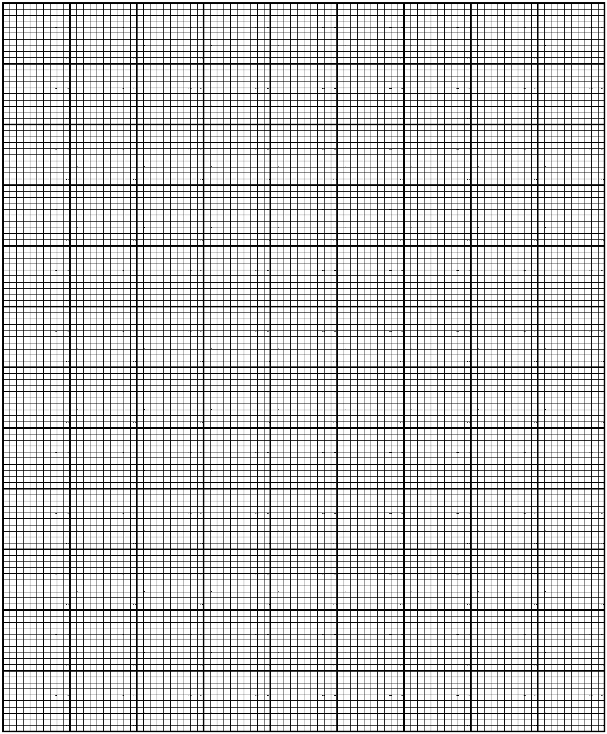

b. A family is likely to have a baby boy or a girl during all the three consecutive births. If the probability of the family to have a baby boy is 0.55. Calculate the probability of the family having:
i. at least 2 boys (5 marks)

ii. at most 1 boy (5 marks)

- a. A body of mass 5 kg is acted on by a constant force F for 10 seconds. Given that initial velocity is -2i – 18j + 13k and final velocity is 8i – 6j + 3k Calculate the
- force F (5 marks)

ii. Magnitude of F (3 marks)

b. A figure below shows four forces acting on a particle which is in equilibrium

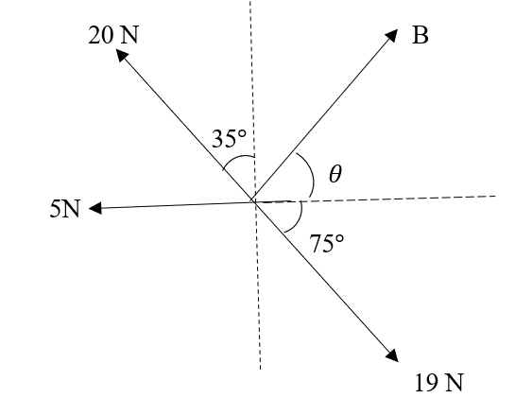
Calculate the values of force B and angle $θ$ (12 marks)

END OF QUESTION PAPER

